**Social Network Analysis Glossary**

*Adapted from*

Brian V. Carolan, “Key Terms,” *Social Network Analysis and Education: Theory, Methods & Applications* (SAGE, 2014, http://www.sagepub.com/carolan/study/materials/KeyTerms.pdf);

Datavu, “Introduction to Network Analysis terminology” (<http://datavu.blogspot.com/2013/10/sna-social-network-analysis-basic.html>);

Katharina Zweig, “An Introductory Course on Network Analysis” (<https://sites.google.com/site/networkanalysisacourse/schedule/an-introduction-to-centrality-measures>).

**Basic Terms**

**Social network**

A finite set (or sets) of actors and the relations defined on them. It consists of three elements: (1) a set of actors; (2) each actor has a set of individual attributes; and (3) a set of ties that defines at least one relation among actors.

**Graph**

A common way to visually represent social networks, consisting of two dimensions: actors and relations (also called nodes and edges).

**Node**

Nodes are the entities in graph (also called vectors). For example, if we consider Facebook friends as a graph, then every friend is a node.   
  
**Edge**

These are the relationships between nodes. For example, if we consider Facebook friends as a graph then every friendship is an edge.

*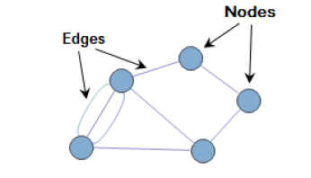Image via http://semanticommunity.info/AOL_Government/Social_Media_-_Six_Degrees_of_Separation_and_Now_Even_Less*

**Types of Graphs**

**Undirected graph**

When the relationship is always valid in both directions, then it is called undirected graph. If Dave is friends with Raj on Facebook, then Raj is also friends with Dave.

**Directed graph**

When the relationship may not be valid in both directions (connecting nodes), then it is called a directed graph. If Bill is following Steve on Twitter and Steve is not following Bill, the relationship is directed.

*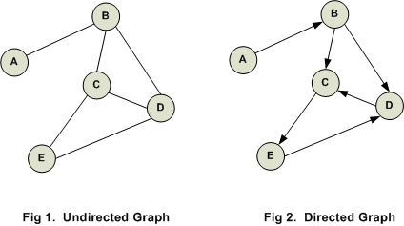Image via http://www.codediesel.com/wp-content/uploads/2012/02/d-graph1.gif*

**Weighted network**

A network in which the edges between nodes have weights (corresponding to, e.g., the strength of a relationship) assigned to them.

**Unweighted network**

A network in which the edges between nodes do not have weights assigned to them.

*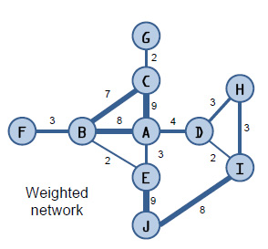Image via http://blogs.sas.com/content/sascom/files/2011/10/weighted-network2.jpg*

**Single-mode graph**

A type of graph in which all nodes belong to the same category. For example, in a graph of Facebook friends, each node is a person.

**Multimode graph**

A type of graph in which all nodes are not of same type. For example, a graph that includes both “buyers” and “sellers” is a multimode (or two-mode, or bimodal) graph.

**Ego network**

When you perform ego network analysis, you select a focal node (an “ego”) and determine its connections to other nodes (which are called “alters”). Each ego is treated as its own case.

*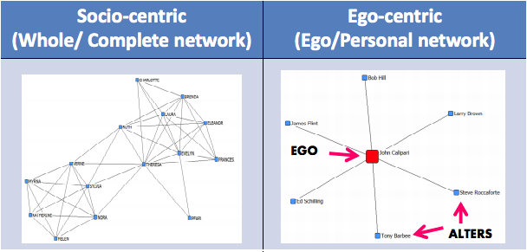Image via http://www.analytictech.com/e-net/pdwhandout.pdf*

**Measures of Graphs or Nodes**

**Size**

A measure of the number of actors (nodes) in a complete or egocentric network.

**Density**

The number of ties in the network reported as a fraction of the total possible number of ties.

**Reciprocity**

The proportion of mutual ties in a network.

**Distance**

The number of “steps” between any two actors in a network.

**Clustering coefficient**

A measure of a network’s actors’ tendency to “group together” into pockets of dense connectivity.

*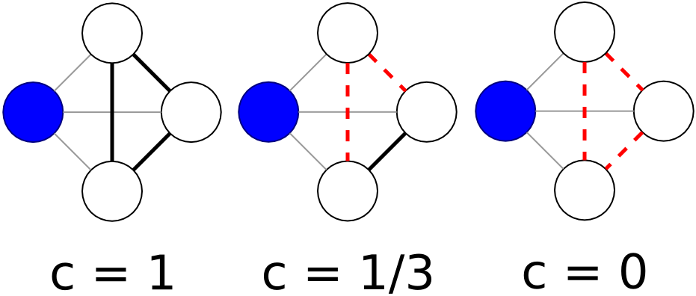In the first image, the blue node has a clustering coefficient of one, because all possible connections among its neighboring nodes have been realized. In the second image, only one of the possible connections has been realized — so the blue node has a clustering coefficient of 1/3. In the third image, none of the neighboring nodes are connected, so the blue node has a clustering coefficient of 0. Image via Wikipedia.*

**Centrality**

There are multiple ways to determine a node’s importance, or centrality. The measure you use depends on how you define centrality. Several of these measures are:

**Degree centrality**

*An important node is involved in large number of interactions.* The number of edges connected with a particular node.

**Eigenvector centrality**

*An important node is connected to important neighbors.* This is a measure of influence of a given node in the whole network. The notion is how well-connected a given node is with other well connected nodes in the network. This is how, for example, Google determines page rank.

**Betweenness centrality**

*An important node lies on a high proportion of paths between other nodes in the network.* Model based on communication flow. A person who lies on communication paths can control communication flow, and is thus important.

**Closeness centrality**

*An important node is typically “close” to, and can communicate quickly with, the other* *nodes in the network.* Length of the average shortest path between a given node and all other nodes in a graph.